1. Summarize chapters 5 and 6 (5. DATA TYPES and 6. VARIABLES) in the text book.

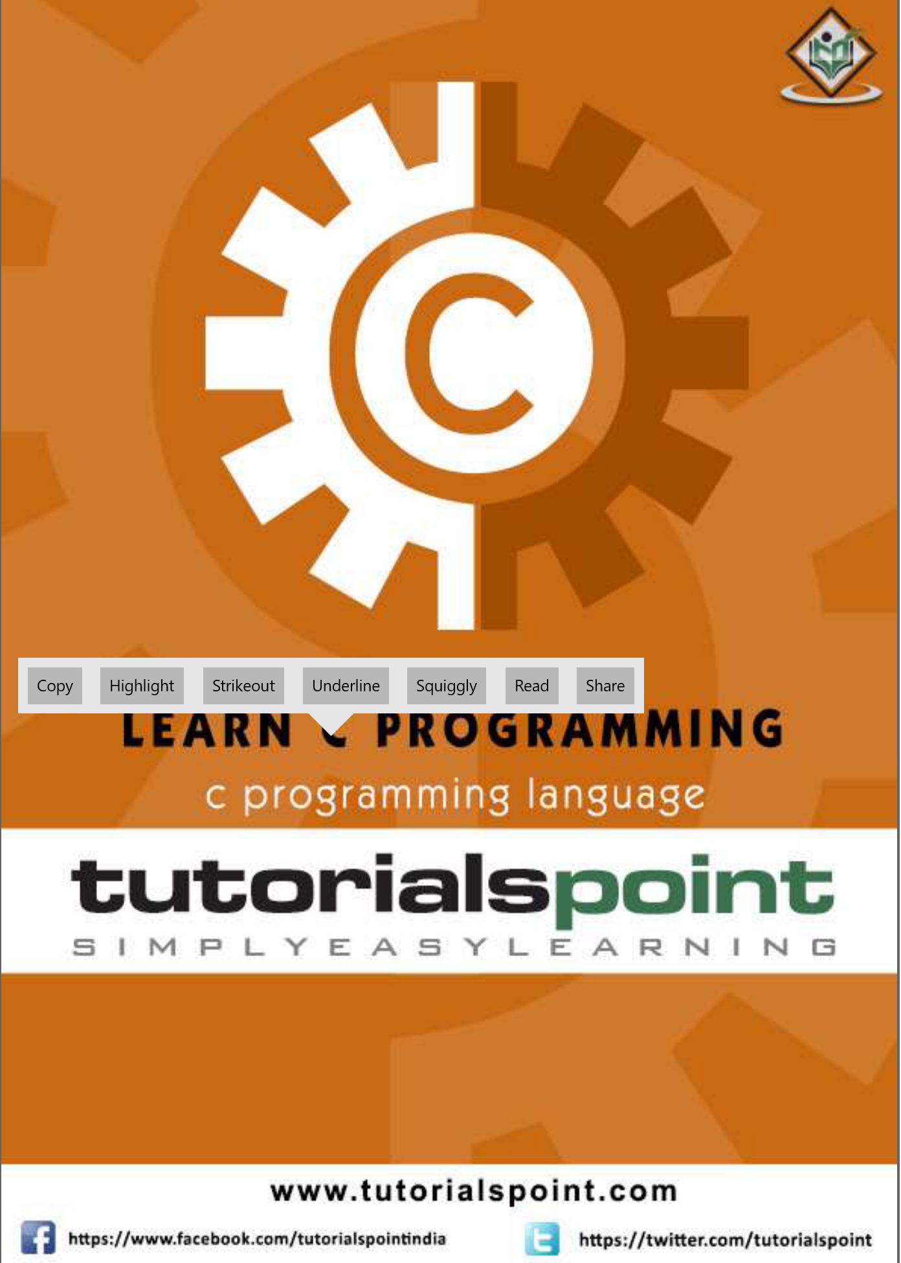

1. Submit your own program based on all the sample codes in each chapter (5 and 6) provided in the textbook. And take a picture of the solutions and attach the picture to the assignment file.